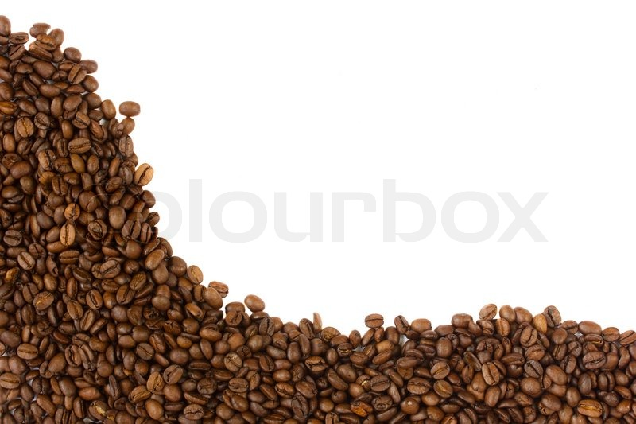

Buying Fair Trade
In today’s world, more than 27 million people are enslaved. Many of these
people work without pay in the agricultural sector, toiling in dangerous
conditions that damage their health and safety, not to mention the environment
and the economies of their local communities. While slaves produce many of the
products we consume every day, two of the most profoundly unjust supply
chains are linked to the products we hold most dear; coffee and chocolate.

When you purchase goods that are Fair Trade, you take a stand against these conditions and vote with your money for the ethical treatment of the men, women, and children who produce our groceries. Fair Trade is a social movement and a certification verifying that the items you have purchased were produced in safe, environmentally sustainable conditions where workers are given freedom and fair compensation for their efforts. This is a movement that promotes the safety of workers, the economic well-being of communities in the developing world, and the protection of our planet’s natural resources. And you can contribute to this amazing social change by buying fair trade coffee and chocolate for your home and office.
Attached is a list of quality Fair Trade coffee and chocolate products and where to buy them. You will notice that they are comparable in price and availability to unethically sourced products, but do a world of social good.

Cheers!

Fair Trade Coffee

Brand | Price | Where to buy
 | Ground Beans
Equal Exchange | About $9.50/bag | EqualExchange.coop
Green Mountain Coffee | $8.50/bag | Meijer
Ethical Bean Coffee | $7.50/bag | Amazon
Biggby French Roast & Rwandan | $11/bag | Meijer, Biggby Locations
The Coffee Fool | $8/bag | Amazon
Death Wish; The World's Strongest Coffee | About $12/bag | Amazon
Melitta | $10/bag | Amazon
Archer Farms | $8.49/bag | Target
Batdorf & Bronson Coffee Roasters | $12.75/bag | Batdorfcoffee.com
Larry's Beans | $12/bag | Amazon
 | K-Cups and Pods
Green Mountain Coffee | $15/box of 24 | Meijer, Keurig.com
Eko Cups | $24/box of 40 | Jet.com
Wolfgang Puck | $10.50/box of 54 | Amazon

Fair Trade chocolate
Brand | Price | Where to buy
 | Individually Wrapped
Jer’s Chocolate | $8/4 oz | jers.com
Equal Exchange Chocolate Minis | $8/4 oz | equalexchange.coop /products/chocolate
Sjaak's | $.39 each | sjaaks.com
Endangered Species Bug Bites | $40/box of 64 | amazon.com
Scharffen Berger | $63.33/box of 200 | scharffenberger.com

